Throughout the semester we have made use of signal generators, mostly the Instek generators We have modified the signals from those generators in countless ways. It is time to see how to generate a time varying voltage for ourselves. This lab will explore two different oscillator circuits and give you an idea how an oscillator works.
First find the comparator that you built at the end of the last lab. It will be the heart of our first oscillator, a Relaxation Oscillator. Leave it set up and build the next circuit nearby.

Task 1: Relaxation Oscillator
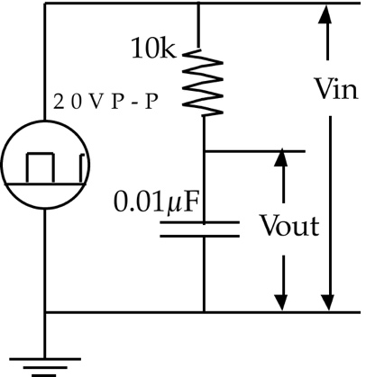
We shall start with the simpler relaxation oscillator. This is actually far more common than the linear oscillator that we shall look at in the later part of the lab. As described in Chapter 24, a relaxation oscillator is made from a comparator with hysteresis and an RC series circuit.
Let us start with the RC circuit. We met this a long time ago and it may be good to refresh our memories. Build the RC series circuit shown on the right. Connect the input to the output of your Instek generator and use your oscilloscope to look at Vin and Vout.

a) Calculate the time constant .
 = 10000 * .01 = 100 microseconds.

b) Set your signal generator to a frequency near f = 1/(10) and paste an image of what you see on the scope below.
F = 1/(1000 microseconds) = 1 Hz.

c) Measure the time constant and compare it to your calculated prediction.
It takes 108 microseconds for the voltage to change from -10V to 2.8V.

d) Do they agree to within the limits that you would expect?
Yes. 8 microseconds is a small enough difference that the error is within the tolerance of the resistor.

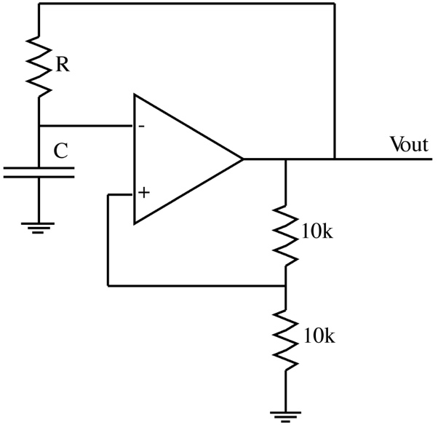

e) Now connect your comparator to the RC circuit to produce the circuit on the left.
This circuit has no input. Connect one channel of your oscilloscope to the V- input of the op-amp and the other to Vout.
Paste an image of the voltages as seen on the scope.
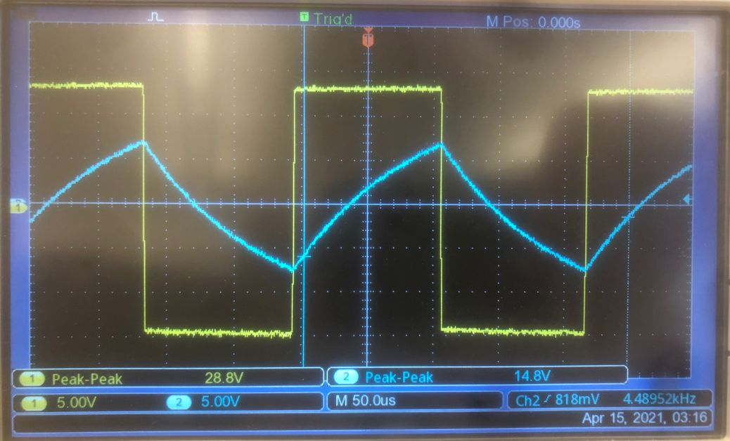

f) Explain the output and account for the frequency that you observe in terms of the RC time constant and the comparator set points.
The capacitor charges until it hits the comparator’s trigger point, then discharges until it hits the comparator’s other trigger point. Since it’s traveling 15V/22.5V from trough to peak, each half-sharktooth takes about one time constant. Thus, the period of the wave is about 2 * tau = 200 microseconds (I used a 10k resistor and a .01uF capacitor) Thus, we expect a frequency of about 1/(200 * 10^-6) = 5kHz, which is not too far off from the measurement above.

Task 2: Linear Oscillator
While a relaxation oscillator produces square and triangle waves, a linear oscillator should produce a sine wave. This requires a filter to set the operating frequency and a linear amplifier to provide the gain needed to create a self-sustaining oscillation. We shall explore the popular Wein-Bridge oscillator, which is based on the Wein-Bridge filter that I described in the section 7.7 in the Electronics book so you may want to refer to that.
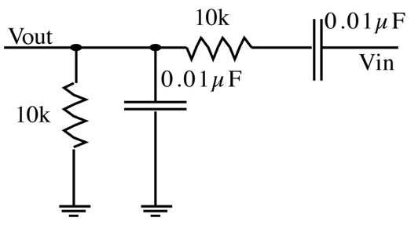

a) Start by building the Wein-Bridge filter shown on the left. NOTE it is drawn with the input on the right and the output on the left. This is the reverse of the usual format, which will make sense in the end.
b) Connect the input to the 50 Ώ output of your Instek signal generator and look at Vin and Vout on your oscilloscope. Set the signal generator to produce 2V P-P sinewaves. Plot the ratio Vout/Vin as a function of frequency from about 10 Hz to about 100 kHz (use a logarithmic frequency scale, as usual).

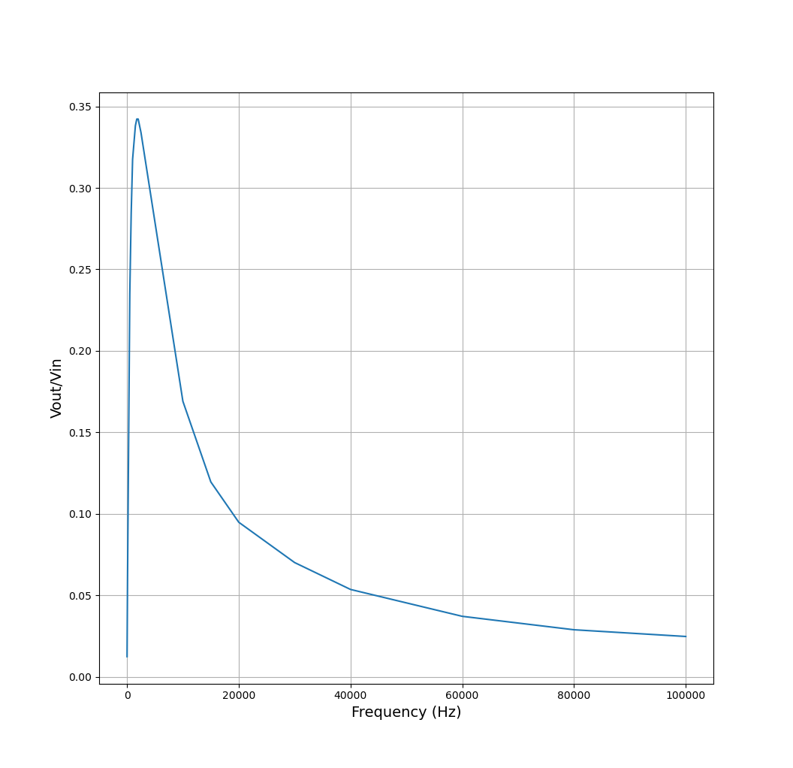

c) At what frequency is the phase shift zero?
The phase shift should be zero at 10000/2pi = 1592Hz, but I measure 0 at 1750Hz.

d) What is the voltage loss (gain) at that frequency? (Answer as ratio, not dB.)
616/1920 = 0.342.

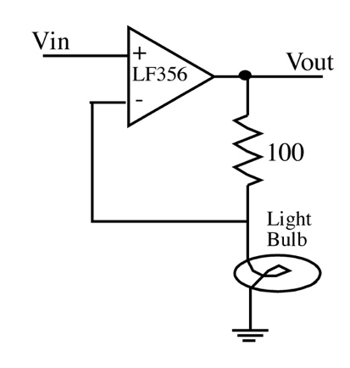

e) The system can be made to oscillate if we add an amplifier that has just enough gain to overcome the loss in the filter. We need an amplifier with a gain near 3 and a gain that alters depending on the signal strength. Here is such an amplifier. Build this using your usual lightbulb as shown.
Connect the input to your Instek signal generator set to create a sinewave at about 1 kHz. Make a graph of the gain of the circuit as a function of the amplitude of the output sine wave. You have to keep the amplitude BELOW the point where the output starts to clip, where the tops or bottoms of the waves start to flatten.
NOTE:
If you can’t get the gain below 3 try reducing the resistor by putting another resistor (eg. 220) in parallel with the 100.
If you can’t get the gain above 3 then try increasing the 100.

f) Paste your plot of gain vs. amplitude below.

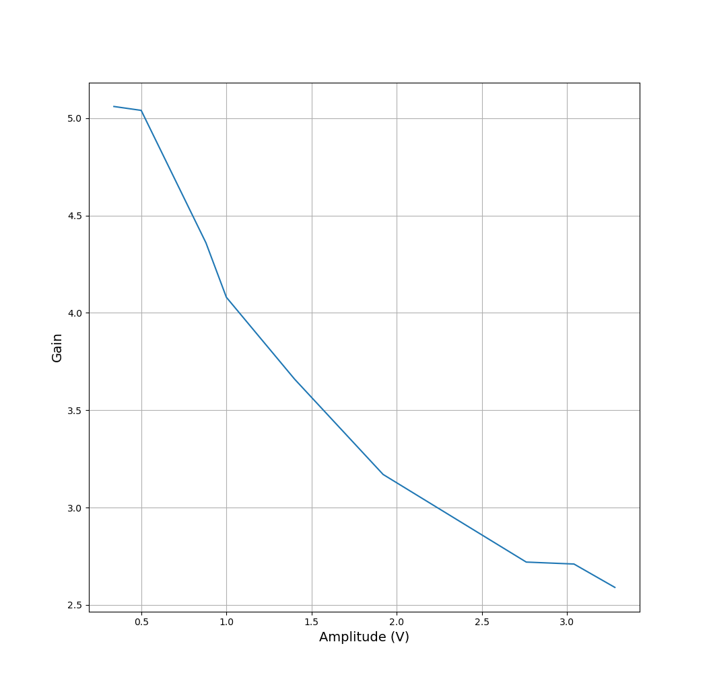

g) It should be possible to sustain stable oscillations at the amplitude at which the amplifier gain equals the filter loss and at the frequency at which the phase shift is 0.
Predict the output amplitude and frequency of the final oscillator from your data.
The output amplitude will be , and the output frequency will be 1750Hz

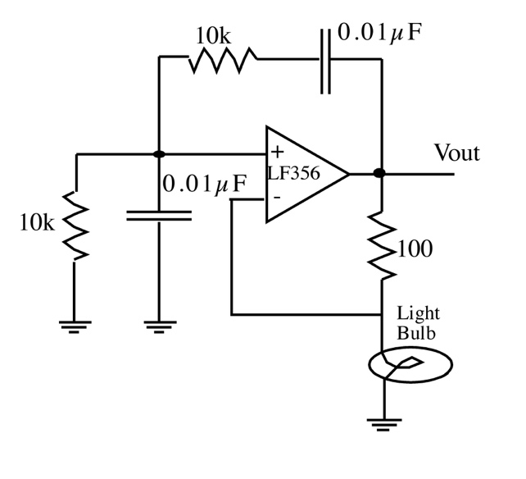

h) Finally connect the filter and the amplifier to make a complete Wein-Bridge oscillator as in the figure. Look at its output on your scope and paste an image below.

i) Compare the output amplitude and frequency with your predicted values.

j) Comment on the quality of the output. Is it a good sine wave?

